Assignment 3 :- Build & Deploy gameoflife.war file on slave-1 and slave-2 with the help of declarative pipeline

Step 1 :- Launch 2 Instances as slave-1 & slave-2 and configure with below commands –

# sudo yum install java java-1.8.0-openjdk-devel.x86_64 -y

# sudo yum install git -y

# download tomcat server under web-server directory

# download apache-maven-3.8.6

# created directory as project to clone game-of-life project from remote repository

Tool configuration for Jenkins Slave

Step 2 :-

1st configure the tool in master or global tool configuration

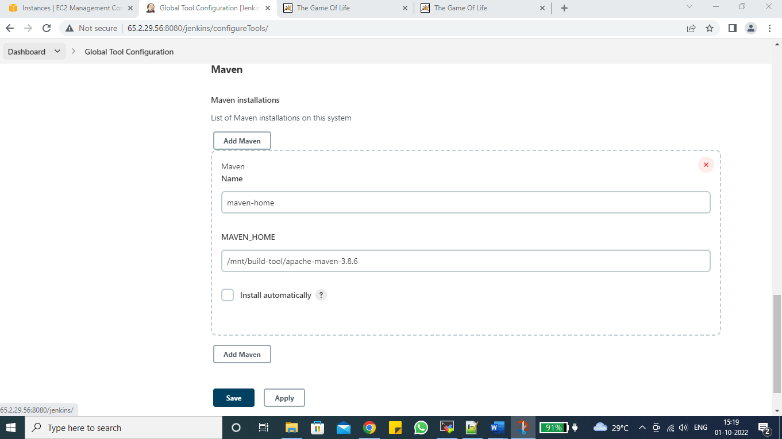

Step 3 :-

Then create a Node as slave-1 & slave-2 and under the slave-1 & slave-2 configuration try to update the tool, maven drop down will only come when we have global tool configuration is updated.

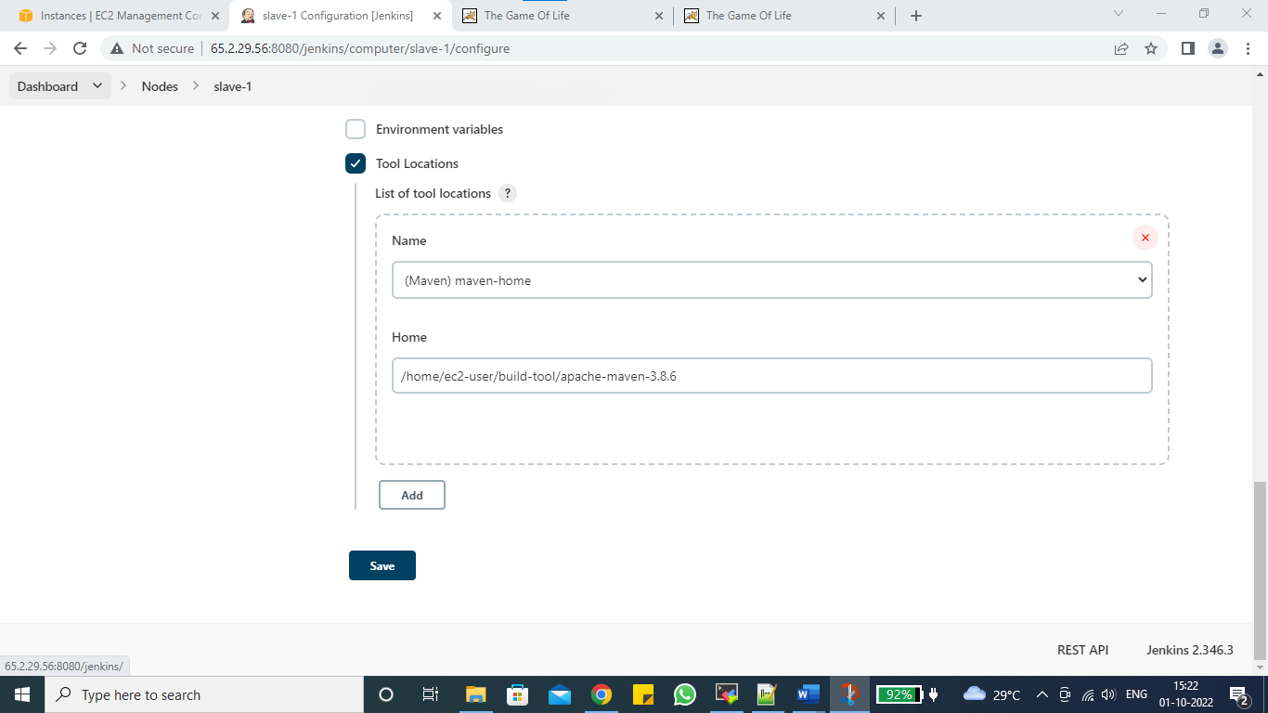

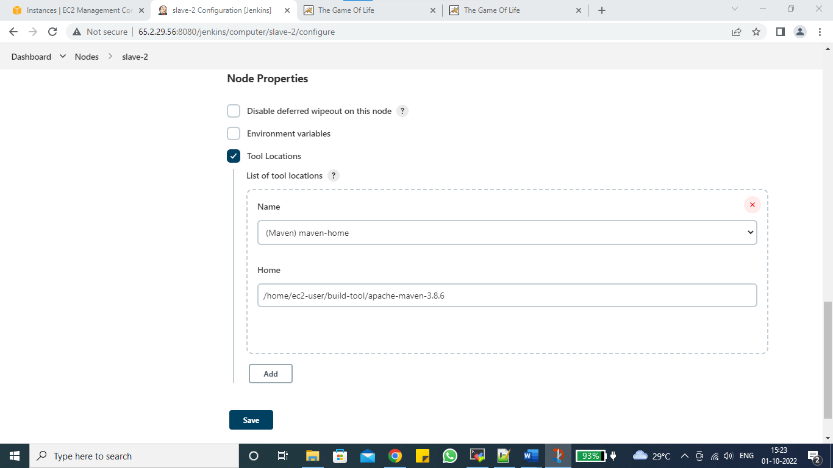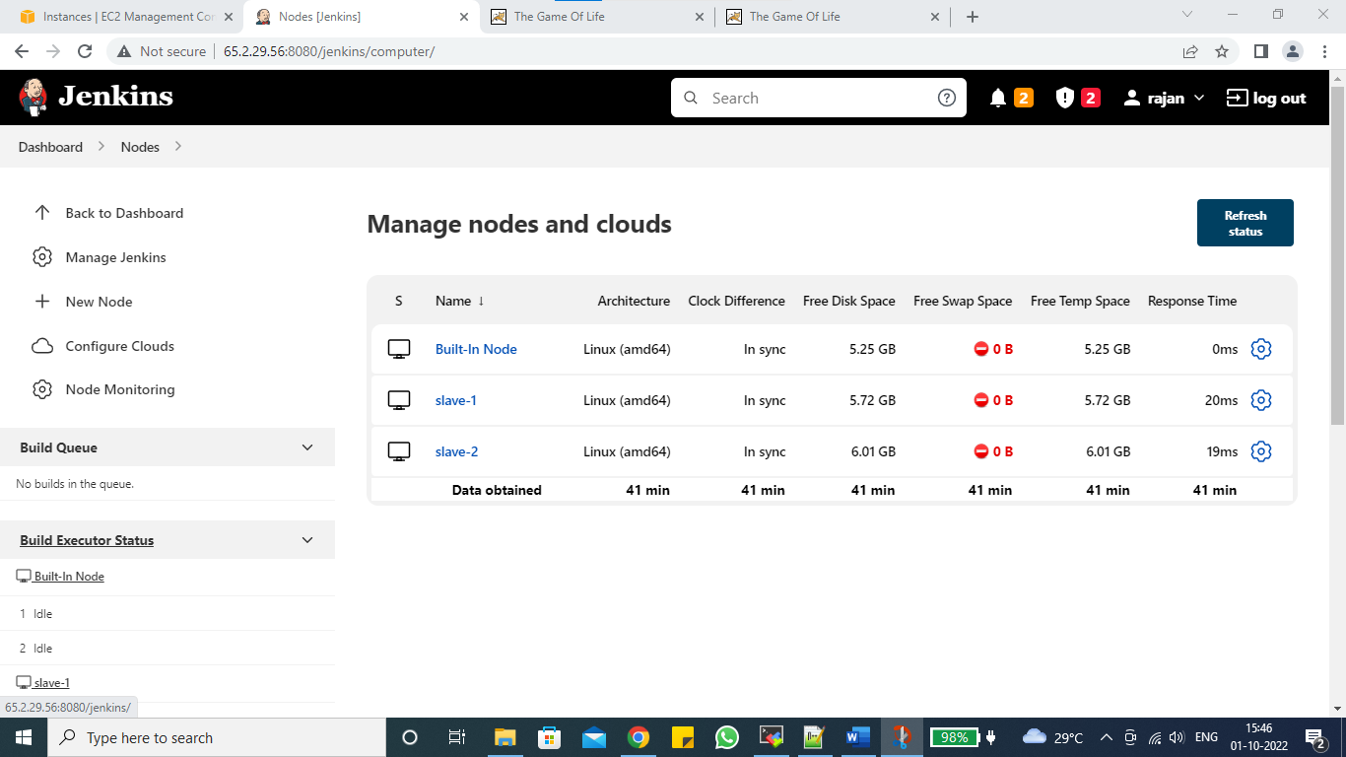

Step 4 :-

Now I will create a pipeline job for slave-1 & slave-2 with the help of declarative pipeline

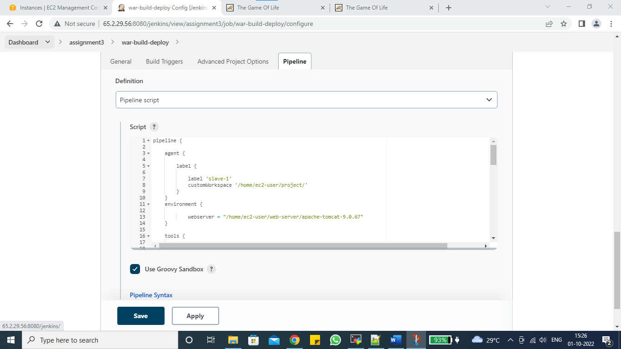

pipeline {

agent {

label {

label 'slave-1'

customWorkspace '/home/ec2-user/project/'

}

}

environment {

webserver = "/home/ec2-user/web-server/apache-tomcat-9.0.67"

}

tools {

maven "maven-home"

}

stages {

stage ('parallel-stages') {

parallel {

stage ('slave-1') {

steps {

sh "rm -rf *"

sh "git clone https://github.com/rajans123/game-of-life.git" // clone game-of-life

sh "cd game-of-life && mvn clean install" //build game-of-life

sh "cp -r game-of-life/gameoflife-web/target/gameoflife.war $webserver/webapps" //deploy gameoflife.war

sh "chmod -R 777 $webserver"

sh "cd $webserver/bin && ./startup.sh && tail -100f ../logs/catalina.out" //start tomcat

}

}

stage ('slave-2') {

agent {

label {

label 'slave-2'

}

}

environment {

webserver = "/home/ec2-user/web-server/apache-tomcat-9.0.67"

}

tools {

maven "maven-home"

}

steps {

dir ('/home/ec2-user/project/') {

sh "rm -rf *"

sh "git clone https://github.com/rajans123/game-of-life.git" //clone game-of-life

sh "cd game-of-life && mvn clean install" //Build game-of-life

sh "cp -r game-of-life/gameoflife-web/target/gameoflife.war $webserver/webapps" //Deploy game-of-life

sh "chmod -R 777 $webserver"

sh "cd $webserver/bin && ./startup.sh && tail -100f ../logs/catalina.out" //start tomcat

}

} }

}

}

}

}

Step 5 :- Build job on slave-1 & slave-2

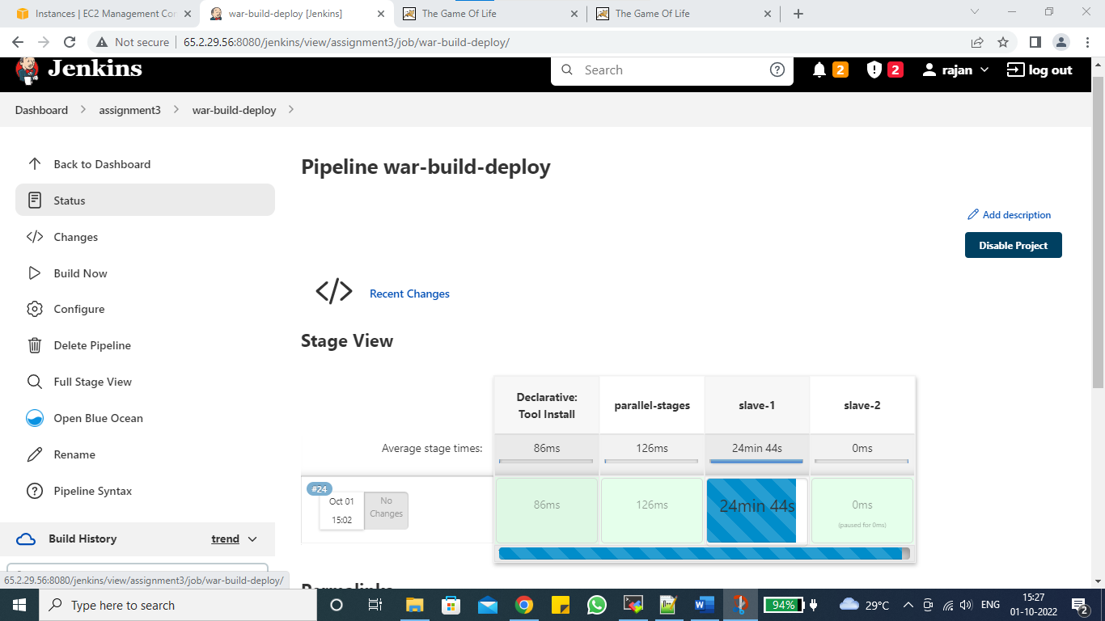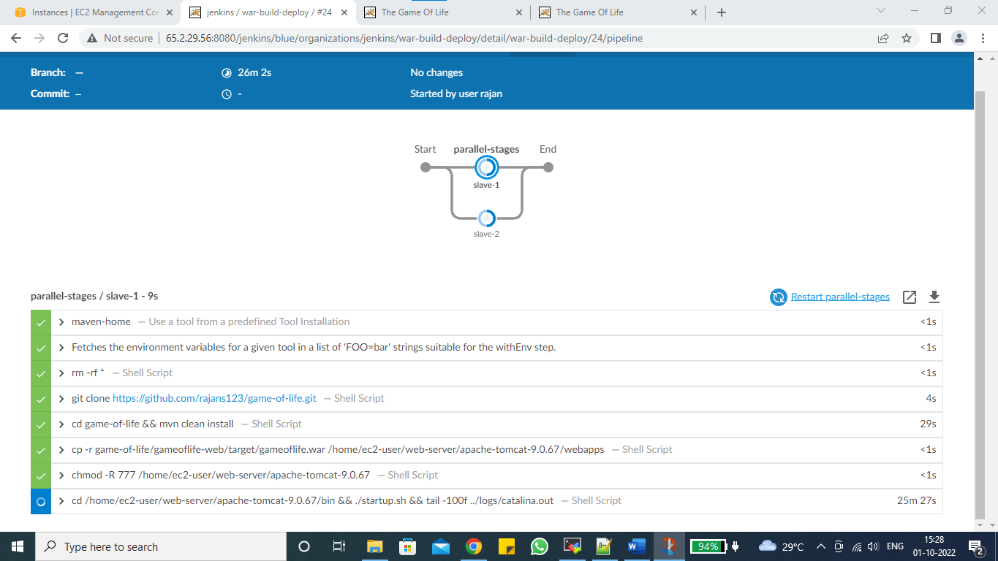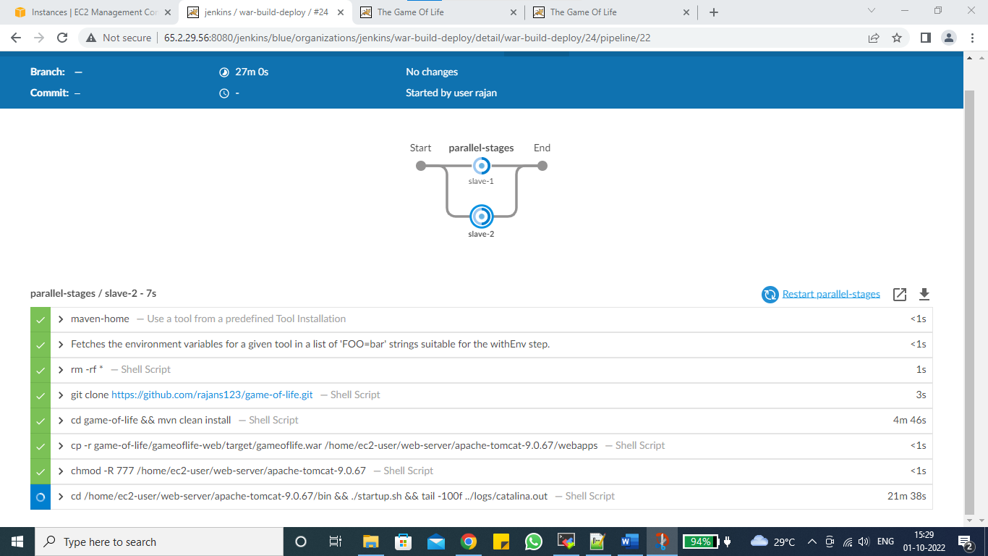

Step 6 :- Deploy job on slave-1 & slave-2

